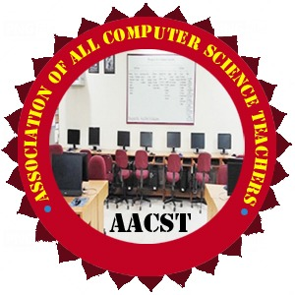
International Journal of Advances and Applications
in Convergent Studies & Transdisciplinary
(IJ-AACST)
Published by: Association of All Computer Science Teachers (AACST)

Author No Objection Certificate (NOC) for Manuscript Submission
Date: ___ / ___ / 20__
To,
The Editor-in-Chief
International Journal of Advances and Applications in Convergent Studies & Transdisciplinary (IJ-AACST)

Subject: Authorization to Corresponding Author for Submission

We, the undersigned co-authors of the manuscript entitled: _________________________________________________________ _____________________________________________________________________________________________________________________________
hereby state that:
- We have contributed to the conception, design, execution, and/or interpretation of the research and manuscript.
- We have read and approved the final version of the manuscript.
- We have no objection to the submission of this manuscript to IJ-AACST for review and possible publication.
- We authorize the Corresponding Author (Name: _________________________________________________________, Email: _______________________________________) to communicate with the Editorial Office, respond to reviewers, and make decisions on behalf of all co-authors regarding this manuscript.
- Manuscript is original, has not been submitted or published elsewhere, and complies with all ethical and academic standards.

Author Details and Signatures
S. No. | Name of Author | Institute /Research Center | Email ID | Signature
1
2 | `
3
4
5
6
Note: Digital or Scanned Signature are acceptable.
Corresponding Author (Authorized):
Name: ___________________________________
Email: ___________________________________
Notes for submission: Signature: ______________________________
- All co-authors must sign this NOC.
- A scanned copy should be uploaded along with the manuscript.

